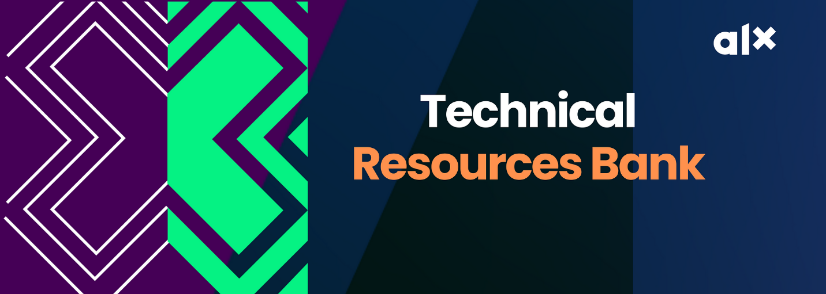
Here you’ll find all the additional learning materials, and updates from your Technical Mentors
AWS CHEAT SHEET
https://tutorialsdojo.com/aws-cheat-sheets/
AWS CLOUD ADOPTION FRAMEWORK (AWS CAF)
WEEK 1 (INTRODUCTION, CLOUD CONCEPTS OVERVIEW)
Intro To Cloud Computing - https://www.youtube.com/watch?v=M988_fsOSWo https://www.youtube.com/watch?v=mxT233EdY5c https://www.freecodecamp.org/news/what-is-cloud-computing-beginners-guide/
Who Is an AWS Cloud Engineer https://oxla.io/cloud-engineer-all-you-need-to-know/
Do well to use it as a reference material along with your Canvas classes. Feel free to reach out if you have any clarifications to make.
##########################################################
WEEK 2 (Cloud Economics and Billing, AWS Global Infrastructure Overview, AWS Cloud Security)
AWS Service - AWS official service catalogue
https://oxla.io/quick-overview-of-the-most-essential-aws-services/ https://leanylabs.com/blog/aws-overview/
AWS Shared Responsibility
https://www.w3schools.com/aws/aws_cloudessentials_sec_sharedresponsibilitymodel.php
AWS Global Infrastructure Map:
https://aws.amazon.com/about-aws/global-infrastructure/#AWS_Global_Infrastructure_Map
https://quizlet.com/297715421/aws-global-infrastructure-flash-cards/
AWS BILLING
https://docs.aws.amazon.com/awsaccountbilling/latest/aboutv2/billing-what-is.html https://www.youtube.com/watch?v=PqFW0ZkOPMM
AWS IAM Security
Find it here
https://youtu.be/SOTamWNgDKc
##############################################################
WEEK 3 (Networking and Content Delivery, Compute, Storage)
Intro to VPC
https://www.youtube.com/watch?v=7_NNlnH7sAg
https://www.youtube.com/watch?v=bGDMeD6kOz0
https://www.youtube.com/watch?v=g2JOHLHh4rI
https://www.youtube.com/watch?v=l5qUSj1316M
https://www.youtube.com/watch?v=w6A06U13KzU
Intro to Basic Computer Networking
https://www.youtube.com/watch?v=_IOZ8_cPgu8
https://www.youtube.com/watch?v=E5bSumTAHZE
https://oxla.io/computer-networking-9-interesting-things-you-should-know/
AWS EC2
https://www.youtube.com/watch?v=TsRBftzZsQo
https://www.youtube.com/watch?v=-L6g9J9_zB8
AWS S3
https://www.youtube.com/watch?v=mDRoyPFJvlU
Documentations
Amazon VPC Overview page: https://docs.aws.amazon.com/vpc/latest/userguide/what-is-amazon-vpc.html
Amazon Virtual Private Cloud Connectivity Options whitepaper: https://docs.aws.amazon.com/whitepapers/latest/aws-vpc-connectivity-options/introduction.htm
Confused by AWS Storage Options? S3, EFS, EBS Explained:
###########################################################
WEEK 4 (Databases, Cloud Architecture, Auto Scaling and Monitoring)
Databases (RDS, Aurora and Dynamo DB)
https://www.w3schools.com/whatis/whatis_aws_rds.asp
https://k21academy.com/amazon-web-services/aws-solutions-architect/amazon-rds/
https://explore.skillbuilder.aws/learn/course/external/view/elearning/61/aws-database-offerings
https://explore.skillbuilder.aws/learn/course/external/view/elearning/86/amazon-aurora-mysql-basics
https://explore.skillbuilder.aws/learn/course/external/view/elearning/65/introduction-to-database-migration
https://explore.skillbuilder.aws/learn/course/external/view/elearning/326/amazon-dynamodb-service-introduction
Well Architected Framework - https://docs.aws.amazon.com/wellarchitected/latest/framework/welcome.html https://aws.amazon.com/blogs/apn/the-6-pillars-of-the-aws-well-architected-framework/
AWS AutoScaling - https://aws.amazon.com/autoscaling/getting-started/ https://tutorialsdojo.com/aws-auto-scaling/
AWS Trusted Advisor - https://docs.aws.amazon.com/awssupport/latest/user/trusted-advisor.html
AWS AI/ML SERVICES
https://duplocloud.com/blog/aws-ai-ml-services/
PRACTICE QUESTIONS
All the practice questions in the list below are FREE. So, kindly make good us of them.
https://digitalcloud.training/courses/free-aws-certified-cloud-practitioner-practice-exam/
https://www.whizlabs.com/blog/aws-cloud-practitioner-certification-questions/
https://www.examtopics.com/exams/amazon/aws-certified-cloud-practitioner/
https://portal.tutorialsdojo.com/courses/free-aws-certified-cloud-practitioner-practice-exams-sampler
https://learn.digitalcloud.training/course/free-aws-certified-cloud-practitioner-practice-exam?/
https://www.whizlabs.com/blog/aws-cloud-practitioner-certification-questions/
https://www.examtopics.com/exams/amazon/aws-certified-cloud-practitioner/
https://portal.tutorialsdojo.com/courses/free-aws-certified-cloud-practitioner-practice-exams-sampler/
https://medium.com/geekculture/aws-certified-cloud-practitioner-practice-exam-questions-8c7da4d759af
https://passemall.com/free-aws-cloud-practitioner-practice-exam
https://www.itexams.com/exam/AWS-Certified-Cloud-Practitioner https://free-braindumps.com/amazon/free-aws-certified-cloud-practitioner-braindumps.html

YouTube Practice Questions (Make sure to watch at least 50% of the below videos before attempting the exam)
https://www.youtube.com/watch?v=mLs3cxbLWos&list=PL7GozF-qZ4KeQftuqU3yxvQ-f3eFNUiuJ
###########################################################
AI & ML SERVICES
Go To Youtube or ALX Learning Resources

###########################################################
AWS CLOUD ADOPTION FRAMEWORK
If you ever come across the AWS Cloud Adoption Framework in the CCP Practice questions, do not panic. Here is all you need to know about it for the CCP, and sample questions you may encounter in the exam.

Go To Youtube or ALX Learning Resources

AWS Cloud Adoption Framework are set of practices that AWS put together to make a business’s move to use cloud computing technology much seamless.
They are guides that contains key considerations that an AWS customer needs to consider before migrating their workload to the cloud. The guide includes - involvement level of all the stakeholders in the business’ operations, the flow of communication between the units in the organization, examining factors that ensure that the business is ready to adopt the cloud model of operating, the transitioning method, etc.
According to AWS, there are 6 key perspective when it comes to Cloud Adoption or transitioning. They include:
- Business
- People
- Governance
- Platform
- Security
- Operations

